Task 5: Demonstrate Optional dependency injection using @Autowired(required=false)
• Create a component that may or may not be present
• Inject it using @Autowired (required = false).
• Handle the null scenario gracefully

STEP 1: Create Spring Boot Project
🔹 If using Spring Initializr
- Project: Maven
- Language: Java
- Spring Boot: Latest stable
- Group: com.example
- Artifact: optional-demo
- Packaging: Jar
- Java: 17 (or your version)
- Dependencies:
  - Spring Web
Project Image Structure:
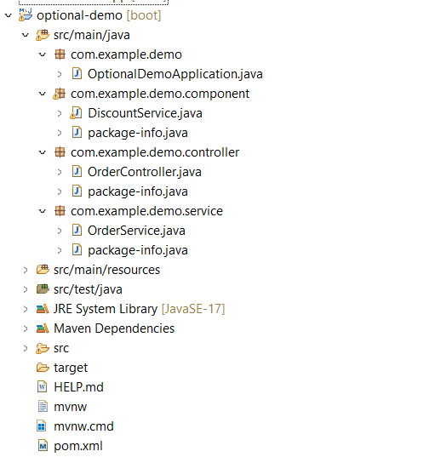

STEP 2: Main Application File
OptionalDemoApplication.java
package com.example.demo;
import org.springframework.boot.SpringApplication;
import org.springframework.boot.autoconfigure.SpringBootApplication;
@SpringBootApplication
public class OptionalDemoApplication {

public static void main(String[] args) {
SpringApplication.run(OptionalDemoApplication.class, args);
}
}

STEP 3: Optional Component
component/DiscountService.java
package com.example.demo.component;
import org.springframework.stereotype.Component;

public class DiscountService {
public String getDiscount() {
return "10% Discount Applied!";
}
}
STEP 4: Service Class
service/OrderService.java
package com.example.demo.service;
import org.springframework.beans.factory.annotation.Autowired;
import org.springframework.stereotype.Service;
import com.example.demo.component.DiscountService;
@Service
public class OrderService {
@Autowired(required = false)
private DiscountService discountService;
public String placeOrder() {
if (discountService != null) {
return "Order Placed Successfully. " + discountService.getDiscount();
} else {
return "Order Placed Successfully. No Discount Available.";
}
}
}
STEP 5: Controller Class
controller/OrderController.java
package com.example.demo.controller;
import org.springframework.beans.factory.annotation.Autowired;
import org.springframework.web.bind.annotation.GetMapping;
import org.springframework.web.bind.annotation.RestController;
import com.example.demo.service.OrderService;
@RestController
public class OrderController {
@Autowired
private OrderService orderService;
@GetMapping("/order")
public String order() {
return orderService.placeOrder();
}
}
STEP 6: application.properties
src/main/resources/application.properties
spring.application.name=optional-demo
server.port=8080
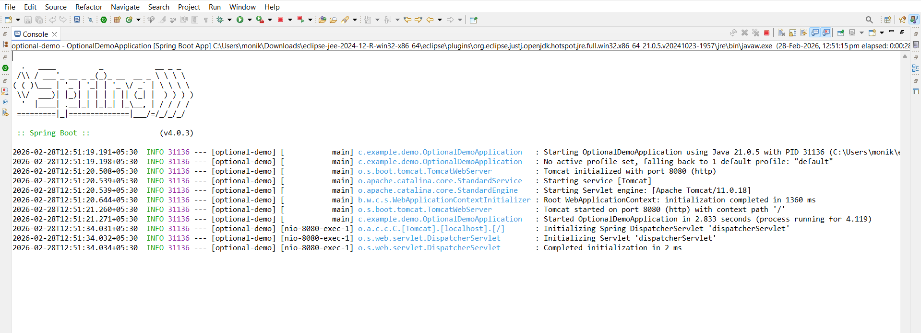
STEP 7: Run the Project
Right-click
Run As → Spring Boot App
http://localhost:8080/order

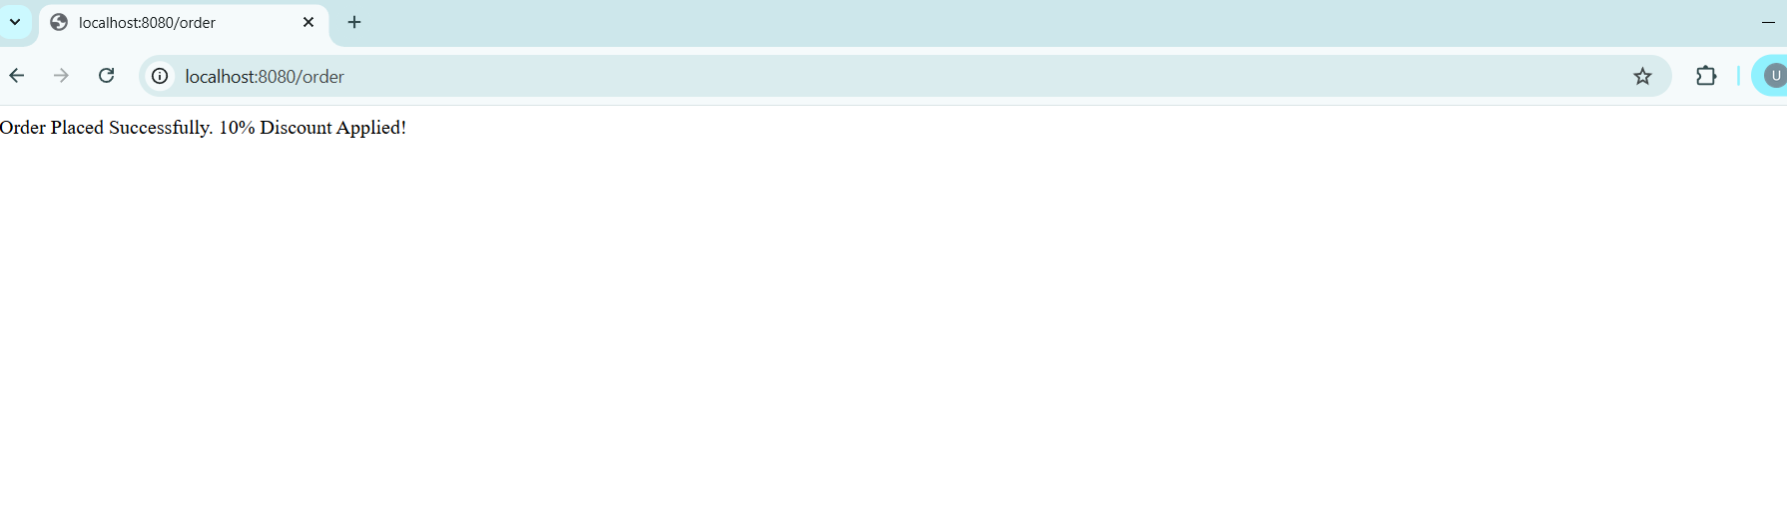

(If You Remove @Component from DiscountService)
